Unit 13 Web Development
Task 3 Develop and Test
Candidate Name: Chris

Task 3 Develop and Test the Website

Assets
- 2C.P4 Prepare assets and content for the website, demonstrating awareness of purpose, listing sources of assets.
- 2C.M3 Prepare assets and content for the website, demonstrating awareness of the users’ requirements with all sources fully referenced.

Asset Table

Asset Name and file Type | What Webpage will this appear on | Description of Asset | Source of Asset
Index.html
./assets/images/Logo.png | All Pages | Purple with a white text saying “MWS” with a white circle | Logo from logomaker.com
./assets/images/index/Pipsnewry.png | Home Page | Logo of a charity | From google Images
Accessorys.html | ./assets/images/accessories
zaggpixel8problackcase.png | Accessories Page | Black Phone Case | Image from idmobile.co.uk
defencescreenprotectorsamsunga34.png | Accessories Page | Screen Protector | Image from idmobile.co.uk
defencebundleforsamsunga14.png | Accessories Page | Clear Case and Screen Protector | Image from idmobile.co.uk
belkin15wfastwirelesscharger.png | Accessories Page | Wireless Charger | Image from idmobile.co.uk
Applelightingtousbacable.png | Accessories Page | Charger Cable with USBA and Lighting Male Port | Image from idmobile.co.uk
appleiphone14siliconcasewithmagsafe.png | Accessories Page | Black Phone Case | Image from idmobile.co.uk

Appleearpodswithlightingconnector.png | Accessories Page | White Earbuds | Image from idmobile.co.uk
Appleairtag.png | Accessories Page | Airtag Picture | Image from idmobile.co.uk
appleairpods2ndgen.png | Accessories Page | White Earbuds | Image from idmobile.co.uk
apple15wmagsafewirelesscharger.png | Accessories Page | White Wireless Charger | Image from idmobile.co.uk
apple20wusbcchargerplug | Accessories Page | White Charger Plug | Image from idmobile.co.uk
Mobilephones.html | ./assets/images/mobilephones
xiaomiredminote12.png | Mobile phone Page | Smartphone | Image from idmobile.co.uk
samsunggalaxyzflip55g.png | Mobile phone Page | Folding Smartphone | Image from idmobile.co.uk
samsunggalaxya34.png | Mobile phone Page | Smartphone | Image from idmobile.co.uk
nothingphone2.png | Mobile phone Page | Smartphone | Image from idmobile.co.uk
motorolamotoe22.png | Mobile phone Page | Smartphone | Image from idmobile.co.uk
motorolag14.png | Mobile phone Page | Smartphone | Image from idmobile.co.uk
Googlepixelfold.png | Mobile phone Page | Folding Smartphone | Image from idmobile.co.uk
googlepixel8pro.png | Mobile phone Page | Smartphone | Image from idmobile.co.uk
googlepixel8.png | Mobile phone Page | Smartphone | Image from idmobile.co.uk
googlepixel7a.png | Mobile phone Page | Smartphone | Image from idmobile.co.uk
appleiphone15plus.png | Mobile phone Page | Smartphone | Image from idmobile.co.uk
appleiphone15.png | Mobile phone Page | Smartphone | Image from idmobile.co.uk
appleiphone14.png | Mobile phone Page | Smartphone | Image from idmobile.co.uk
appleiphone13.png | Mobile phone Page | Smartphone | Image from idmobile.co.uk
Tablets.html | ./assets/images/tablets
Aceracta.webp | Tablet Page | Image of a tablet | Image from currys.co.uk
amazonfire7.webp | Tablet Page | Image of a tablet | Image from currys.co.uk
amazonhdfire8.jpg | Tablet Page | Image of a tablet | Image from currys.co.uk
appleipad2021sg.png | Tablet Page | Image of a tablet | Image from currys.co.uk
appleipad2022.wbp | Tablet Page | Image of a tablet | Image from currys.co.uk
Appleipadairblue.webp | Tablet Page | Image of a tablet | Image from currys.co.uk
Googlepixeltablet.png | Tablet Page | Image of a tablet | Image from currys.co.uk
lenovop11pro.png | Tablet Page | Image of a tablet | Image from currys.co.uk
lenovotabm8.webp | Tablet Page | Image of a tablet | Image from currys.co.uk
Samsungtaba8.webp | Tablet Page | Image of a tablet | Image from currys.co.uk
samsungtabs8+.png | Tablet Page | Image of a tablet | Image from currys.co.uk
Samsungtabs9u.webp | Tablet Page | Image of a tablet | Image from currys.co.uk
Specialoffers.html | ./assets/images/specialoffers
Applearcade.webp | Special Offers Page | Apple Arcade Logo | Image from Apple.com
Applemusic.png | Special Offers Page | Apple Music Logo | Image from Apple.com
Appletv4k.jpg | Special Offers Page | Apple TV Device Picture | Image from Apple.com
Appletvplus.png | Special Offers Page | Apple TV+ Logo | Image from Apple.com
Applewatchseries9.jfif | Special Offers Page | Apple Watch Imag | Image from currys.co.uk
Toshiba50inchSmart4KTV.webp | Special Offers Page | TV with a FireTV Interface | Image from Amazon.co.uk

Develop Your Website
- 2C.P5 Develop a website containing at least 8 interlinked web page, demonstrating audience and purpose.
- 2C.M4 Develop a website including interactive components, demonstrating awareness of user requirements and taking account of usability.
Web-page 1 (Home Page)
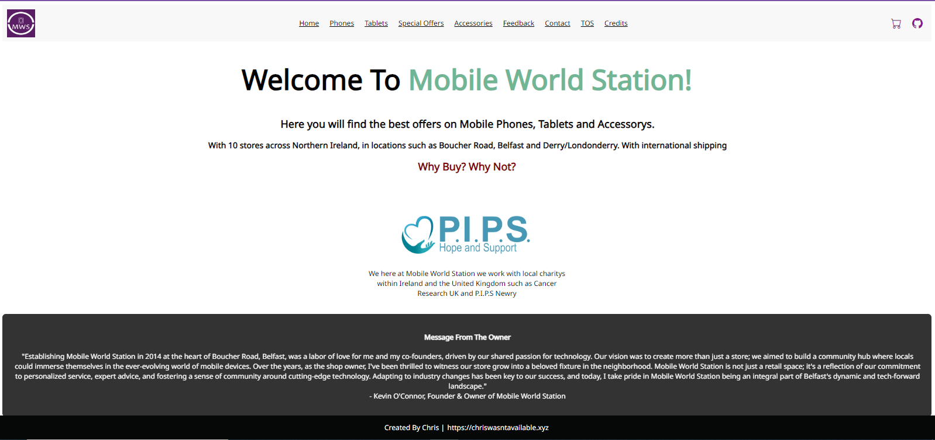
Logo from Adobes free logo maker
Hyperlink
Text made by me from the “Owner”
Action buttons
Colour changing text
Internal Hyperlinks
Text about MWS
Sponsored Charity

Google Chrome 121.0.6167.139/140, 75% Zoom

On the homepage you can see the logo, company name, information on the company, the sponsored charity, an introductory paragraph to make you feel welcome. Action buttons and hyperlinks for easy navigation.

Web-page 2 (Mobilephones Page)
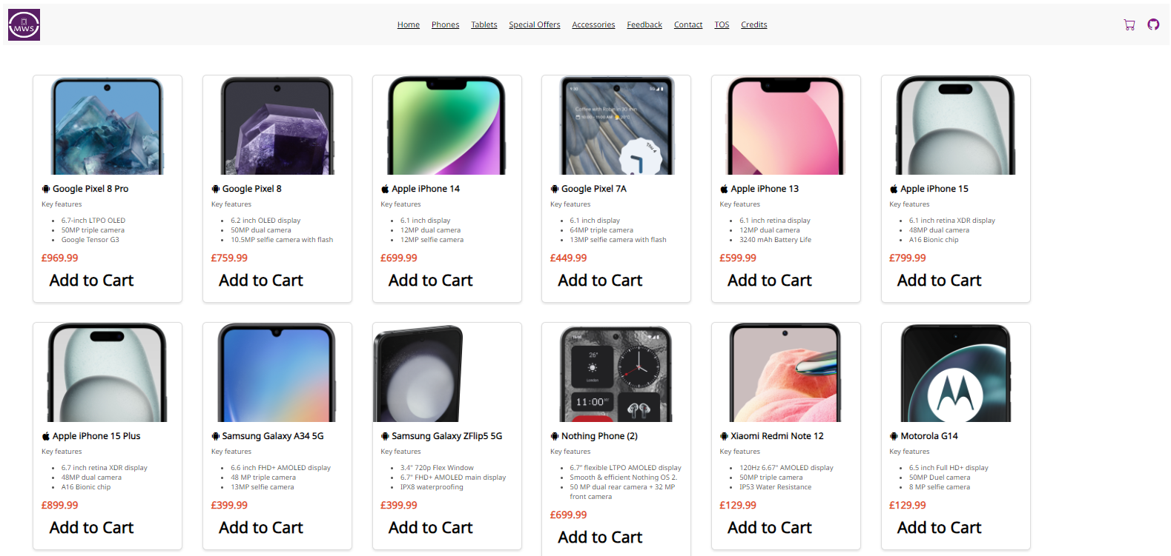
Name Of Product:
Description:
Price:
“Add to Cart” button

Google Chrome 121.0.6167.139/140, 67% Zoom

I have included a wide list of Android and Apple Phones as I am aware some
people would use an Android over an iPhone. I have included specifications of the phones as they are useful to compare phones.
I have included an “Add to Cart” button for people to add items to the cart. This button works using JavaScript.

As before this page contains the same header as before.

Web-page 3 (Tablets Page)
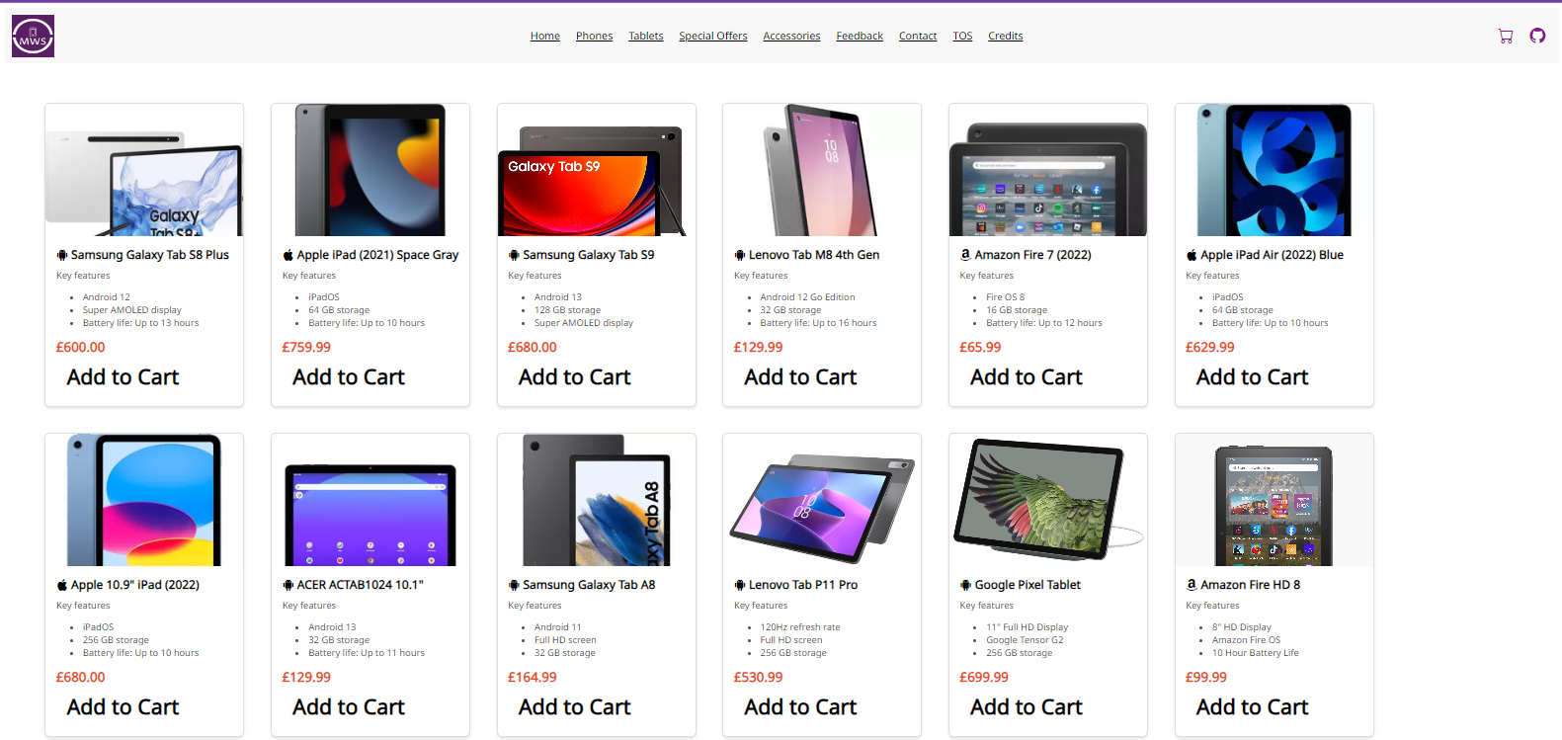
Name Of Product:
Description:
Price:
“Add to Cart” button

Google Chrome 121.0.6167.139/140, 67% Zoom

I have included a wide list of Android, Amazon and Apple Tablets as I am aware some people would use an Android or Fire Tablet over an iPad. I have included specifications of the tablets as they are useful to compare tablets.
I have included an “Add to Cart” button for people to add items to the cart. This button works using JavaScript.

As before this page contains the same header as before.

Web-page 4 (Special Offers Page)
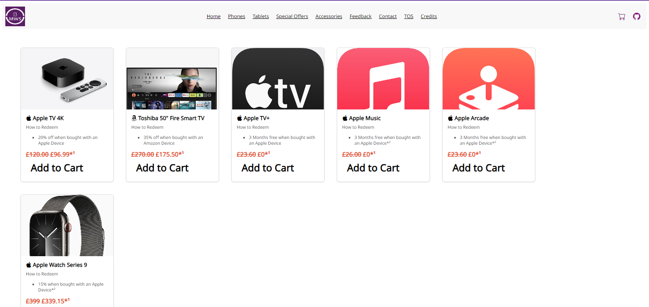
Name Of Product:
Description:
Original Price:
Price:
“Add to Cart” button

Google Chrome 121.0.6167.139/140, 75% Zoom

I have a small list of special offers that are offered when you buy a device. I have included the original price of the items so you know how much you’re saving.
I have included an “Add to Cart” button for people to add items to the cart. This button works using JavaScript

As before this page contains the same header as before.

Web-page 5 (Accessories Page)
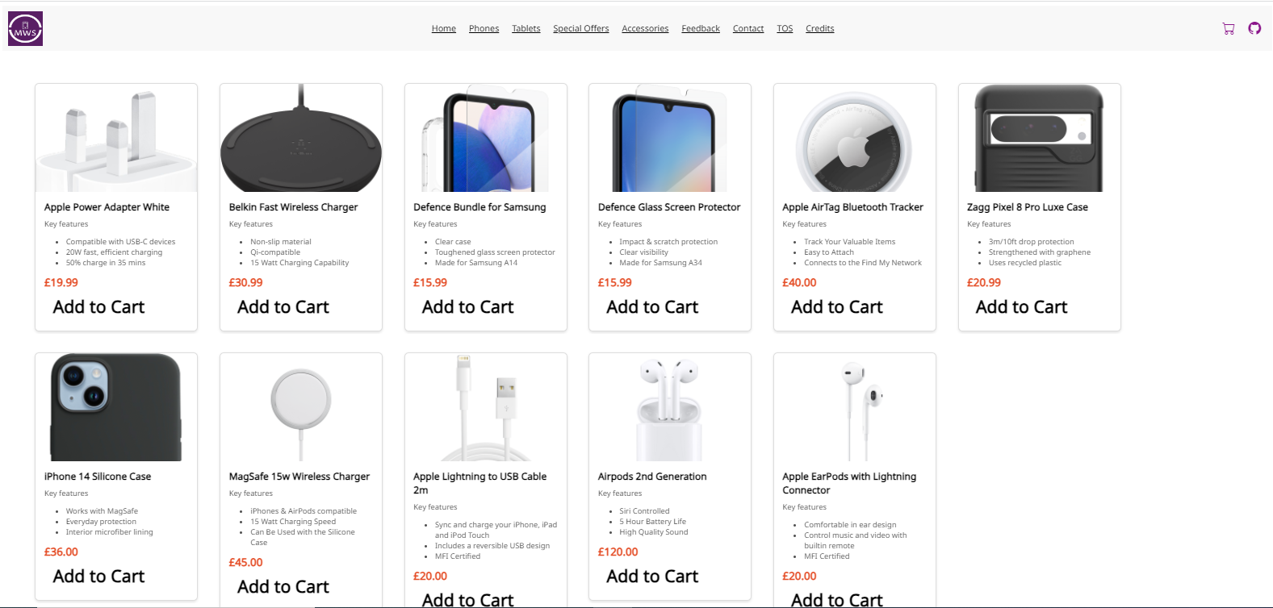
Name Of Product:
Description:
Price:
“Add to Cart” button

Google Chrome 121.0.6167.139/140, 67% Zoom

I have included a wide list of accessories for both Android and iPhone users as I
am aware some people would use an Android over an iPhone. I have included
some small details as they are useful to compare accessories.
I have included an “Add to Cart” button for people to add items to the cart. This button works using JavaScript.

As before this page contains the same header as before.

Web-page 6 (Cart Page)
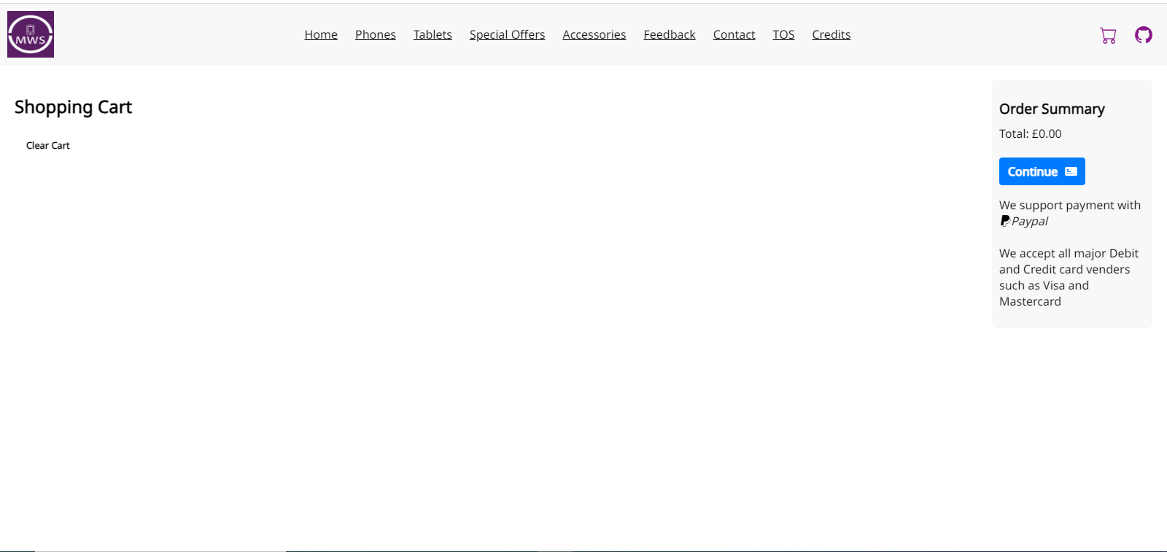
Continue to payment button
Price of all items
“Clear Cart” Button

Google Chrome 121.0.6167.139/140

This webpage mainly runs off of JavaScript as the price of the items are added up with JavaScript. The clear cart page runs off JavaScript and when an item is added
to the cart it is done with JavaScript.
If a payment processer was added it would be PayPal due to its ease of use and
the convenience as I already have a version of this cart that has PayPal integration.

As before this page contains the same header as before.

Web-page 7 (Feedback Page)
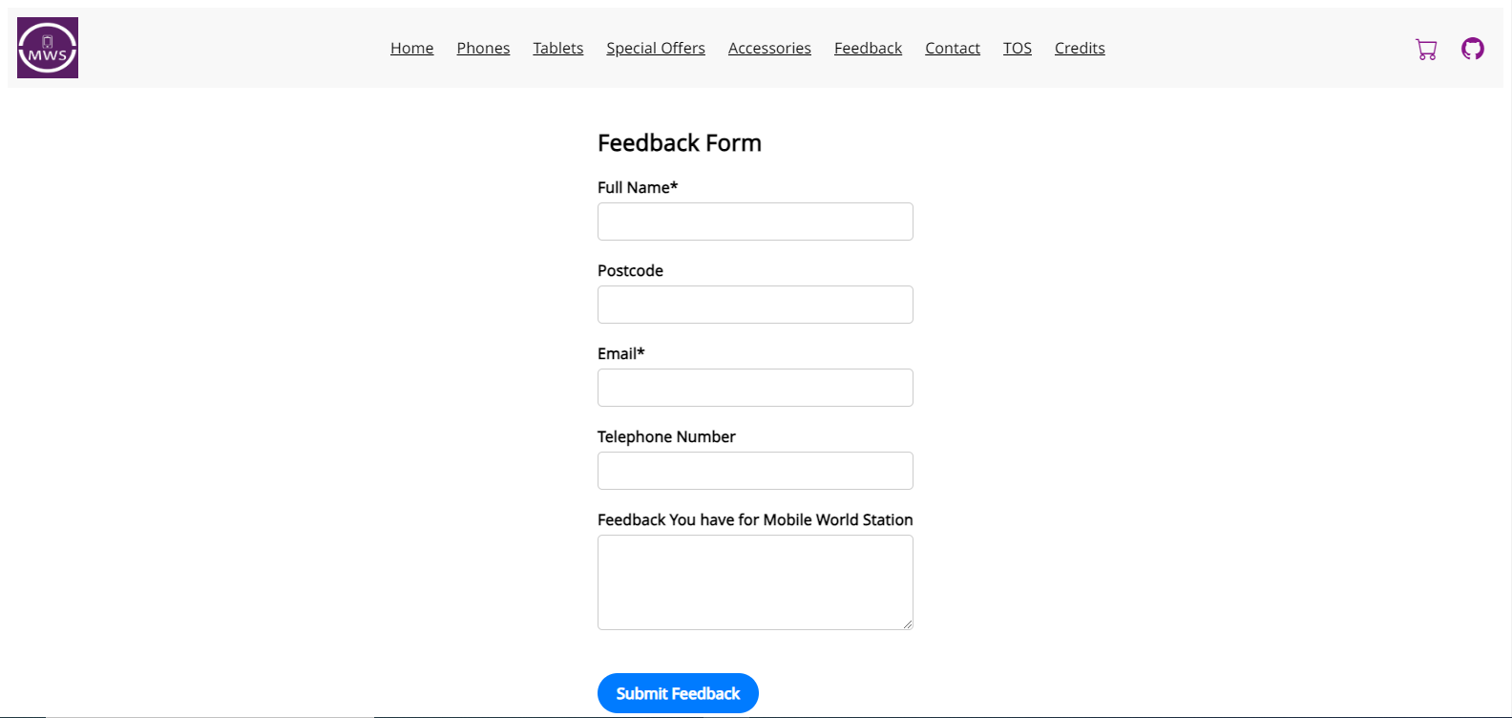
Form input sections for Full Name, Postcode, Phone Number and the feedback for MWS
Submit Button

Google Chrome 121.0.6167.139/140

The form input sections were made using Bootstrap and PHP. The sections with * are required meaning the “Full Name”, “Email”, and Feedback sections are all required.

The “Submit Feedback” button sends the feedback to a .txt file via PHP elsewhere on the webserver so it can be read and added to the home page if needed.

As before this page contains the same header as before.

Web-page 8 (Contact Page)
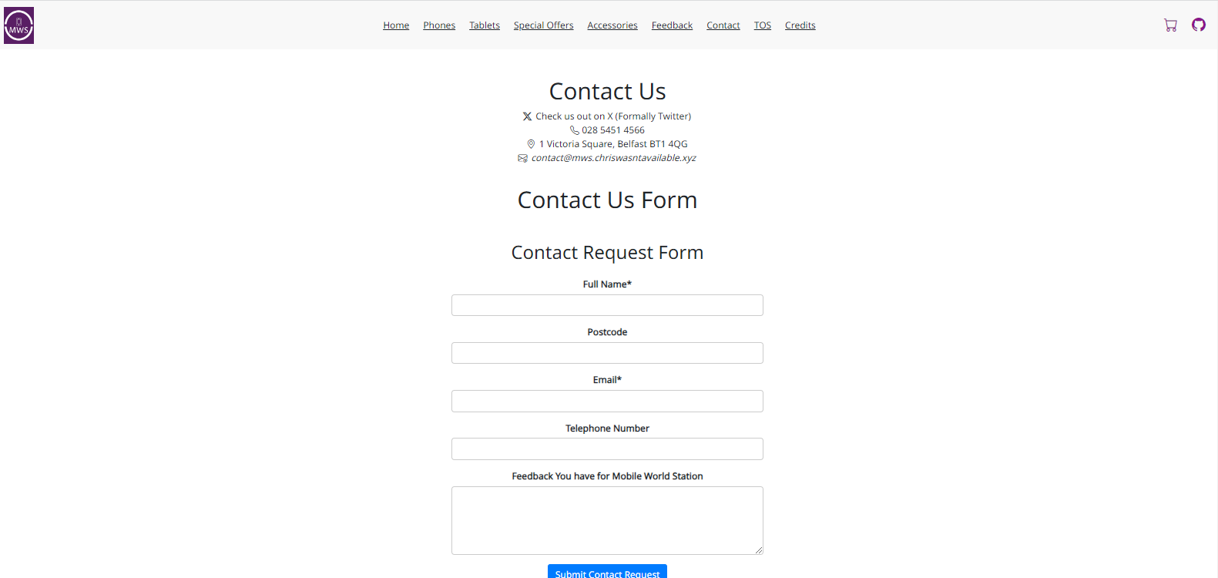
Form input sections for Full Name, Postcode, Phone Number and why you want to contact MWS
Submit Button

Google Chrome 121.0.6167.139/140, 75% Zoom

The hyperlinks on this site are external. They link to X (Formally Twitter), Google Maps, and a mailto: link.

As before this page contains the same header as before.

Web-page 9 (TOS Page)
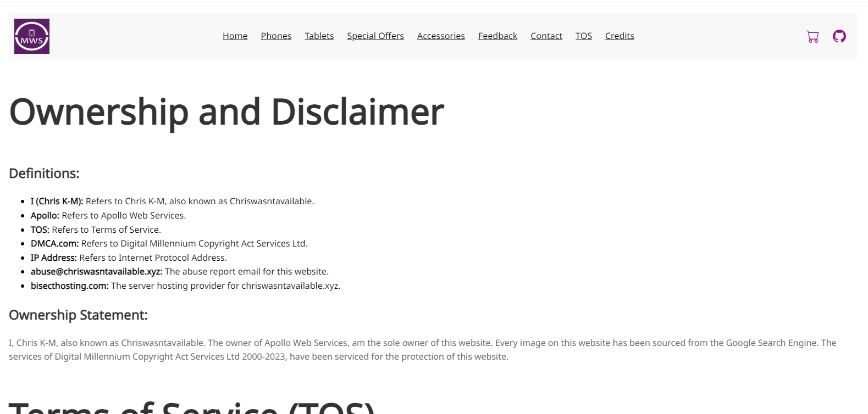
H1 Heading
Unordered HTML List
Paragraph

Google Chrome 121.0.6167.139/140

The H1 heading was made to be big so its noticeable. The Ordered list is to tell people what the definitions mean and the paragraph is the main content.

As before this page contains the same header as before.

Web-page 10 (Credits Page)
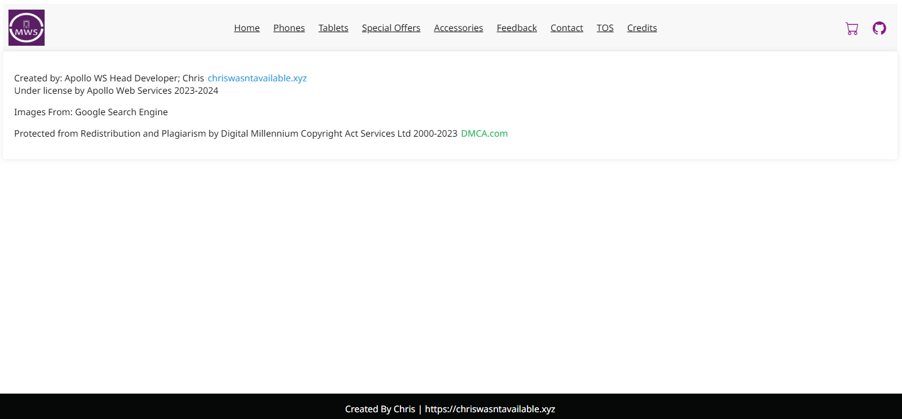
Hyperlink
Hyperlink

Google Chrome 121.0.6167.139/140

The top hyperlink goes to my (the developers) webpage and the bottom hyperlink
goes to dmca.com.
As before this page contains the same header as before.

Main Storyboard

Index.html
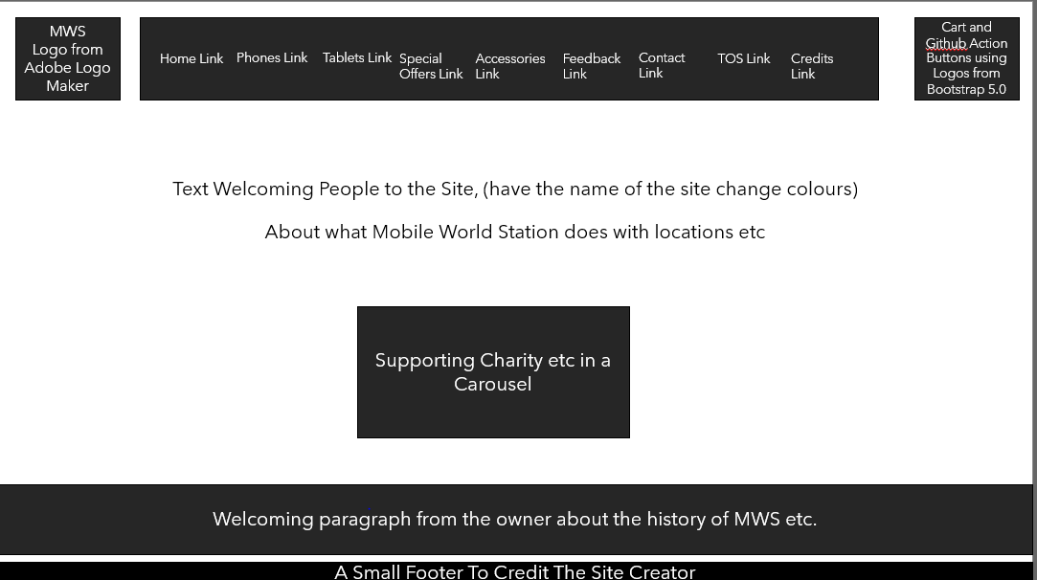

Mobilephones.html
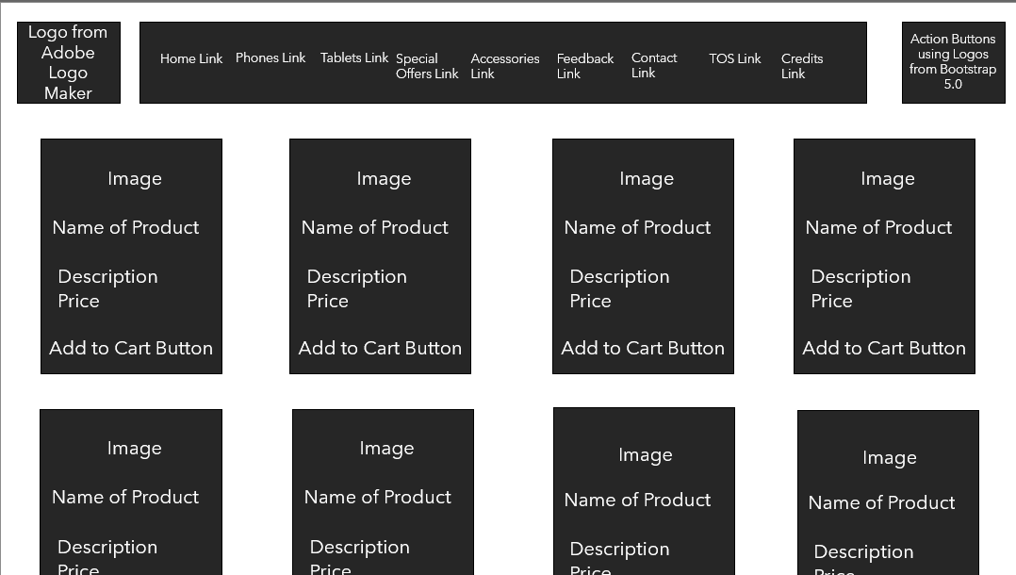
Tablets.html
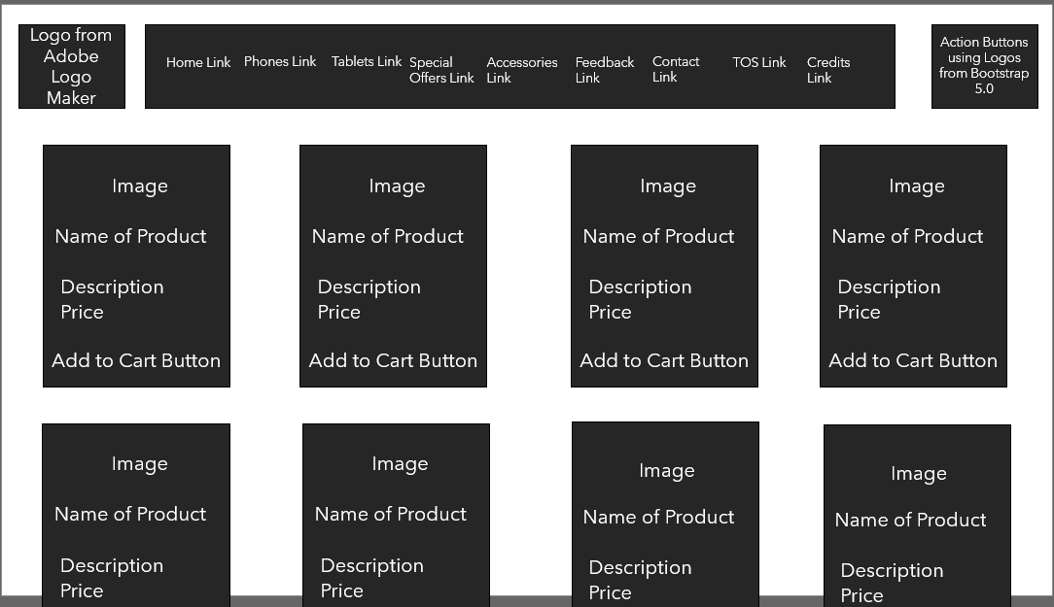
Specialoffers.html
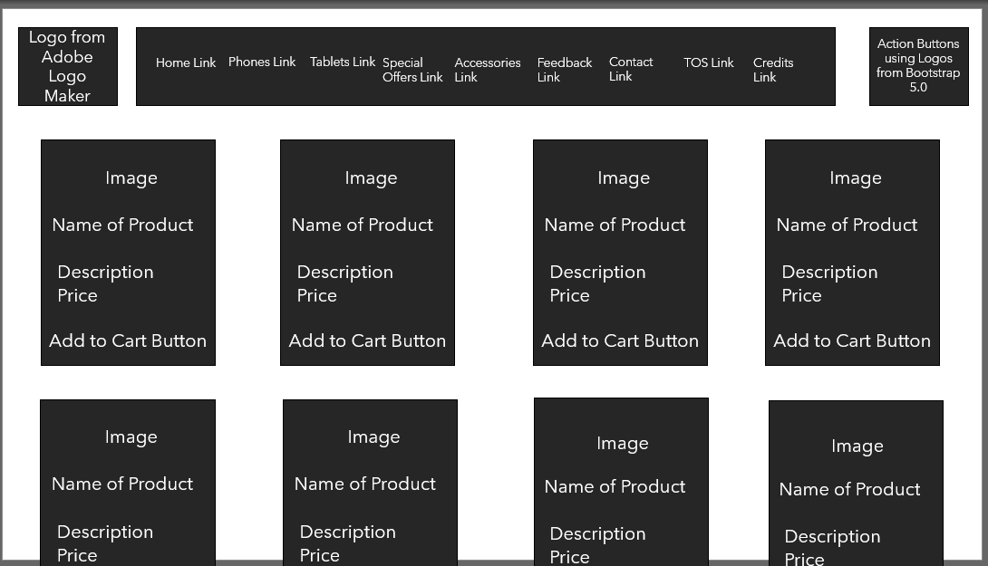
Cart.html

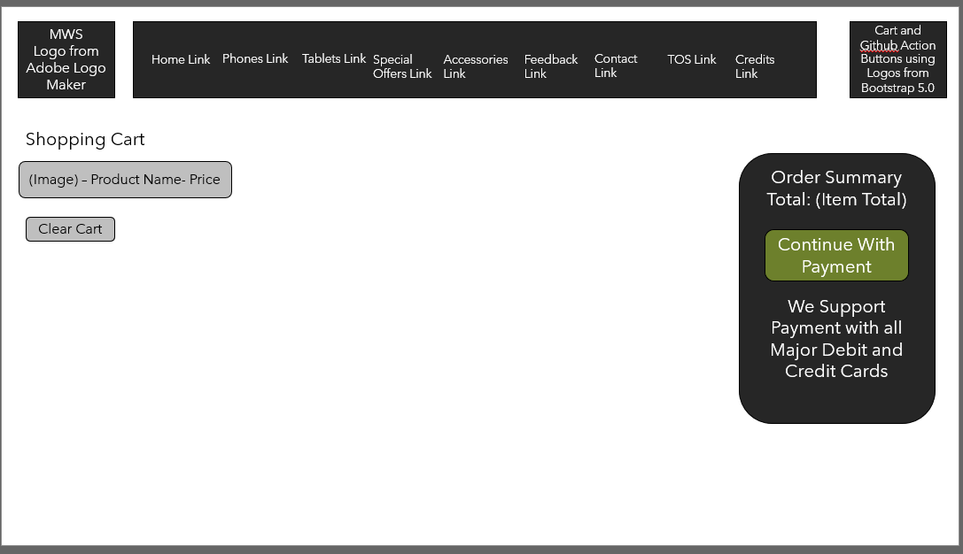

Feedback.html

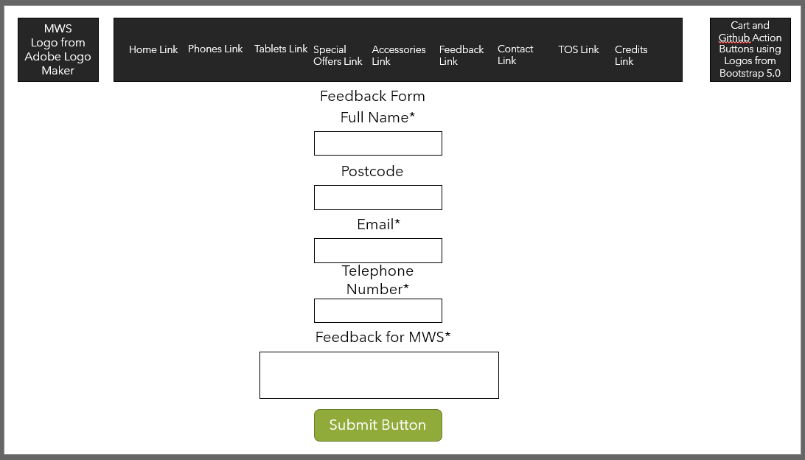

Contact.html
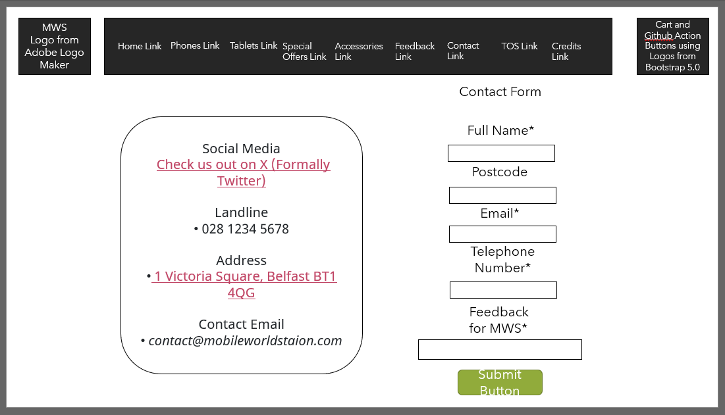

Termsofservice.html
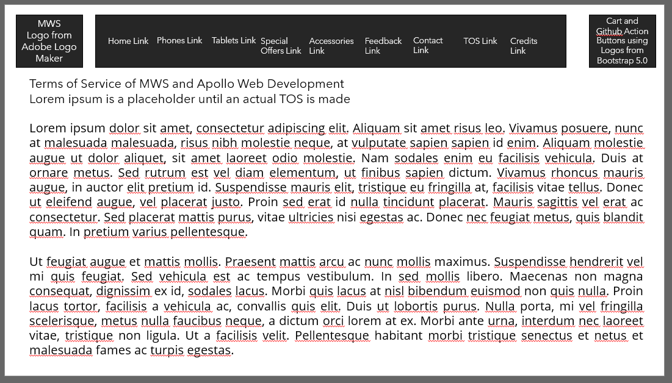

Credits.html

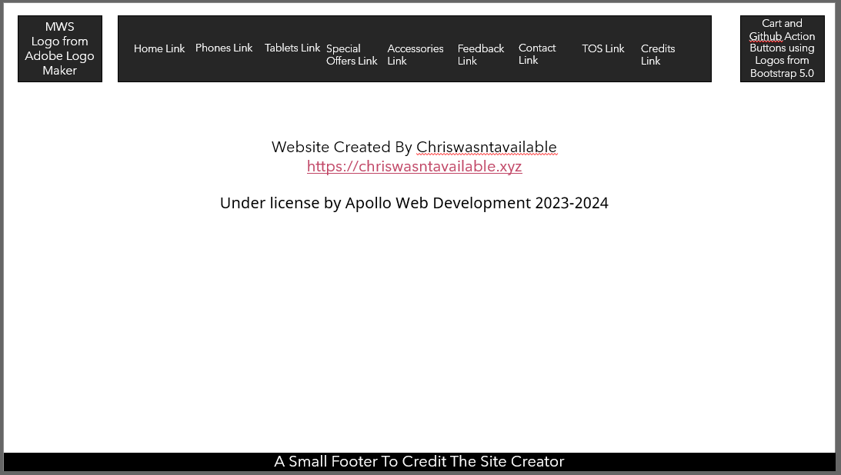

Alt Storyboard

Index.html

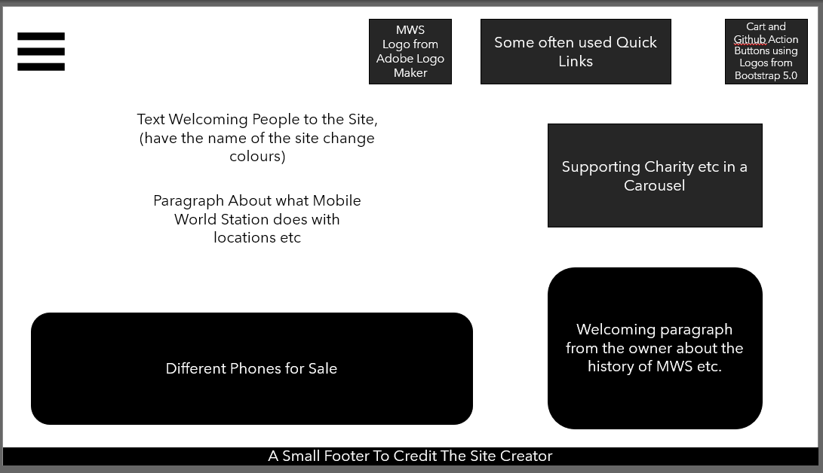

Mobilephones.html

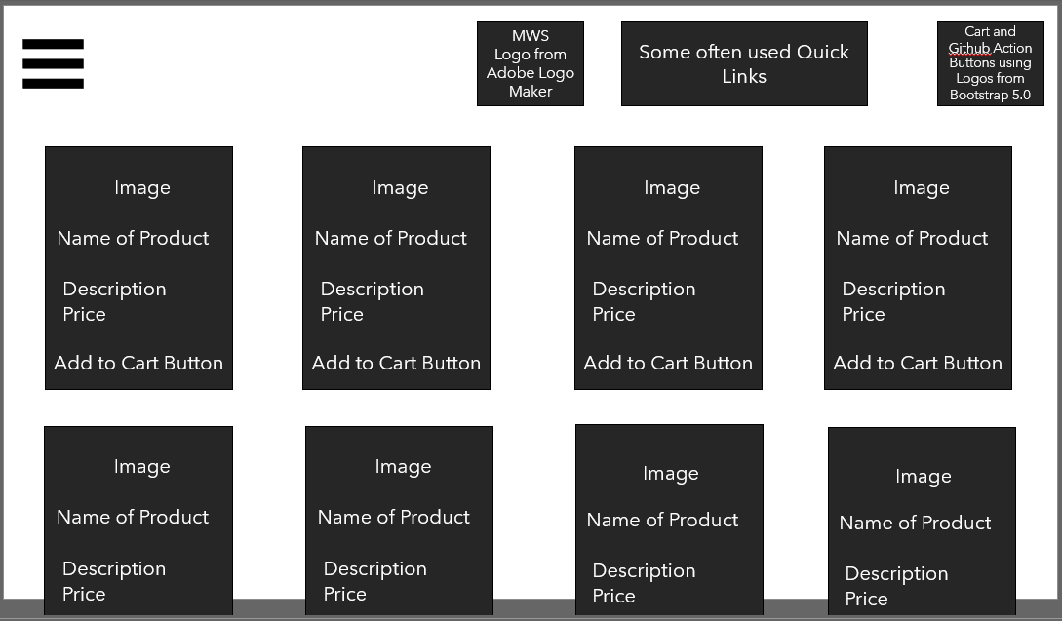

Tablets.html

Specialoffers.html

Cart.html

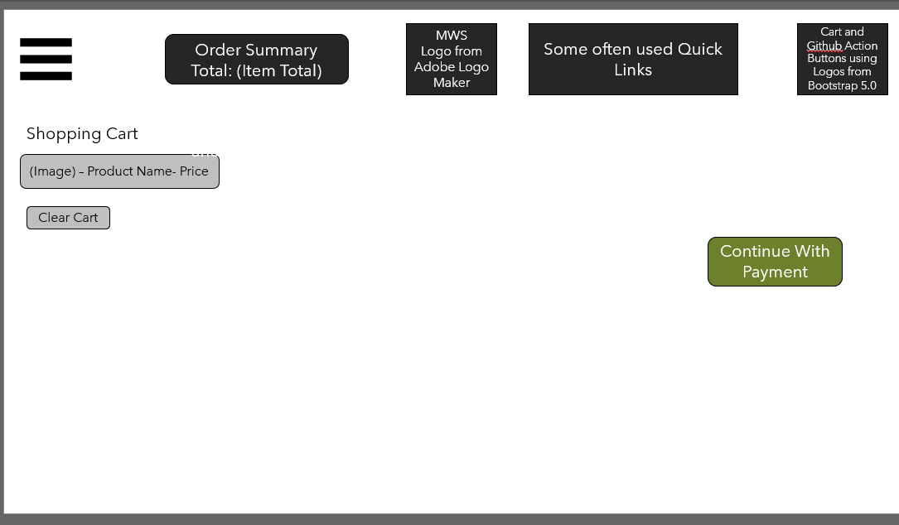

Feedback.html

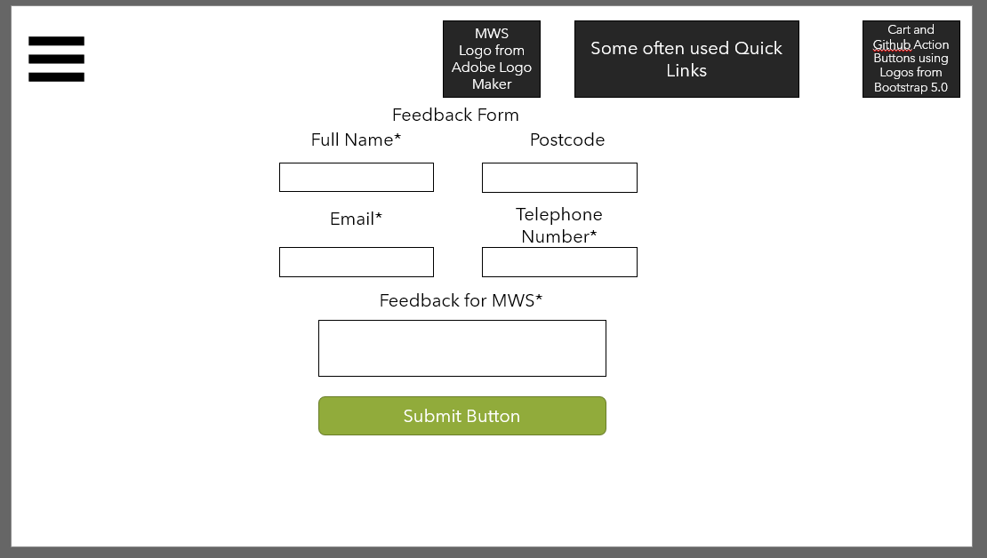

Contact.html

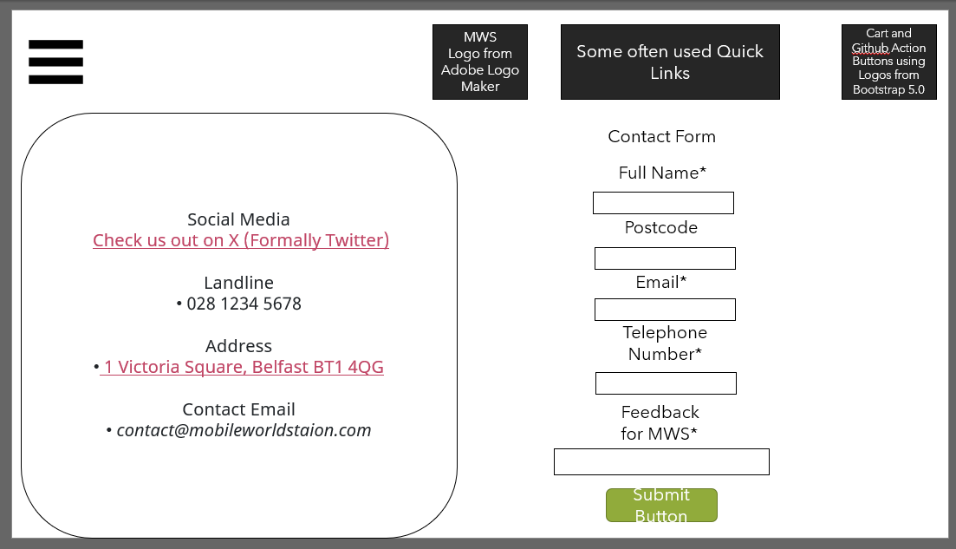
Termsofservice.html
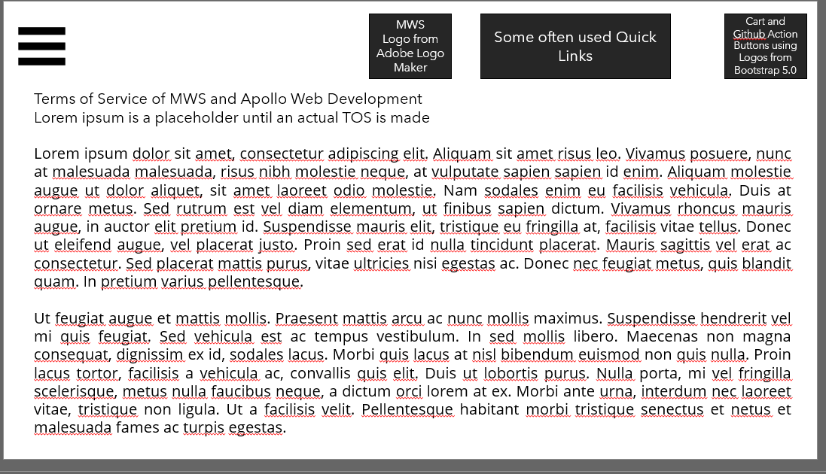

Credits.html

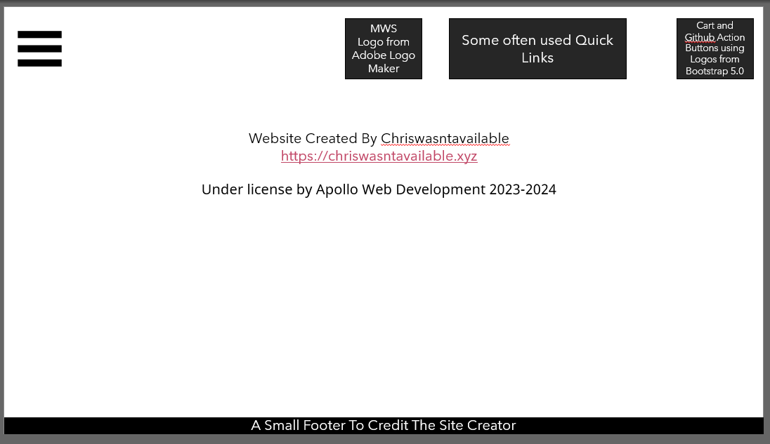

Testing the Website
(3.) 2C.P6 Test the website for functionality and purpose, repairing any faults, and documenting changes.
2C.M5 Test interactivity and gather feedback from others on the quality of the website, and use it to improve the website, showing awareness of user requirements.
(3.) 2C.D3 Refine the website, to improve accessibility and performance, taking account of user feedback and test results.
What is web testing?
Web testing an organized method that enables QA teams to ensure fast and efficient testing for their websites and applications to ensure that it works.

They can rely on automation for web-based or software application testing, reducing the frustration of repetitive and routine tasks.
These tests can compare real-world results with predicted ones to ensure no changes.
Why test a website?
You need to test a website to ensure there are no errors for an end client/user. Some examples for testing a website would be

- Ensuring that all page’s load.
- Ensuring all hyperlinks work, both externally and internally.
- To ensure that interactivity such as filling out a form works.

Part 1 - Testing
Describe the methods you used to test and to improve your website:
Self Testing – ongoing self-reflection/evaluation (testing as you create each webpage and making changes as I develop the site)
Peer Testing (Students in my class) – Let a peer test the website and the functionality of the website.
ICT Teacher – I will get my teachers professional opinion on my webpage.
Independent Assessor – I will get the ICT manager to be an independent assessor to my website so I can get nonbiased feedback and issues to help improve my website

Test Number | Expected Test Result | Browser – Chromium Based | Browser – IE 11
1. | Do are the pages load and function correctly? | Yes | No – I will not be fixing this as IE11 takes up less then 1% of the browser market share, on all modern and on updated browsers the pages work
2. | Background colour consistent on all pages? | Yes | Yes
3. | Navigation Bar in the same position on all pages | Yes | Yes
4. | All interactive buttons work and hyperlinked | Yes | No – This is due to IE not allowing JavaScript to run, I cannot fix this and as mentioned before it would take more time and most likely money to fix then what you’d get from it
5. | Is the layout consistence on all pages? | Yes | Yes
6. | External hyperlinks go to the correct website | Yes | Yes
7. | Text content match the title of the website | Yes | Yes

Part 2
Based on feedback from the above testing I made the following improvements.

What is the improvement being made? | How will this impact the website? | Before | After
Background colour on a part of the site being white while the text is white – Correcting the site so the background on the section is grey | It will make the text unreadable | 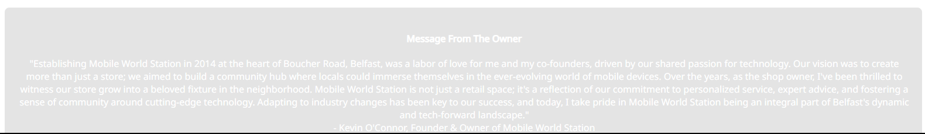 | 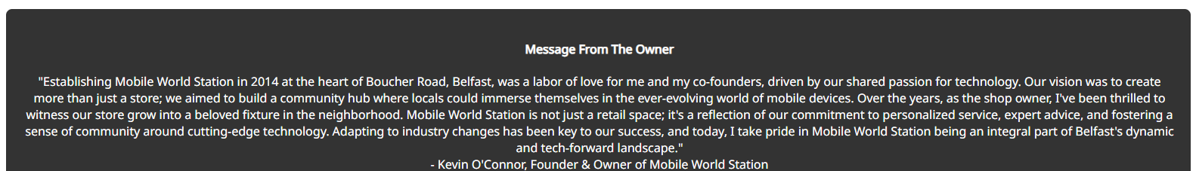
Multiple Times that accessories was spelt like accessorys | It will make the site look unprofessional | 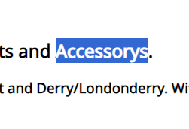 | 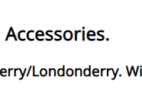
Link is not hyperlinked | Might get the site developer more service |  | 
Improper Credits | Would open the website to a copyright claim due to no crediting | 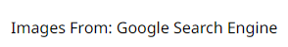 | 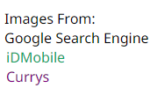
Submitting forms not working | Would not allow people to submit feedback or contact MWS | 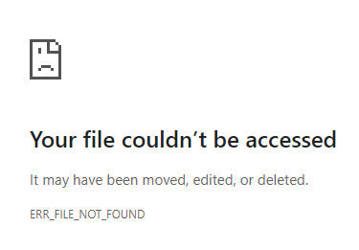 | 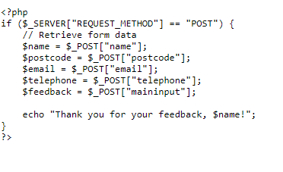  Still cannot submit feedback but  That is due to the website not  Loading on a webserver and is  Just a static page

Peer Assessment Questions
Assessed By: Niall W.
Date of Assessment: 23/04/2024

It is easy to navigate my website?
Yes / No
If no please specify

Do all hyperlinks and interactive buttons work and bring you to the correct page?
Yes / No
If no please specify
Does my website look like it could be used as a professional website?
Yes / No
If no please specify

Is the text on my website easy to read and understandable?
Yes / No
If no please specify

Is the theme on my website consistent across all pages?
Yes / No
If no please specify

Do the assets of my website load and work correctly?
Yes / No
If no please specify

Does the styling of my website look correct?
Yes / No
If no please specify
Does the “Add to Cart” buttons on my website work?
Yes / No
If no please specify

Peer Assessment Questions
Assessed By: Ripon M.
Date of Assessment: 29/04/24

It is easy to navigate my website?
Yes / No
If no please specify

Do all hyperlinks and interactive buttons work and bring you to the correct page?
Yes / No
If no please specify
On the feedback page when submitting it directs you to missing file error.
Developer’s correction: It does not work and leads you to a missing file error as this website is setup to work on a webserver not to be loaded as a static webpage. This has been fixed 30/04/2024

Does my website look like it could be used as a professional website?
Yes / No
If no please specify

Is the text on my website easy to read and understandable?
Yes / No
If no please specify

Is the theme on my website consistent across all pages?
Yes / No
If no please specify

Do the assets of my website load and work correctly?
Yes / No
If no please specify

Does the styling of my website look correct?
Yes / No
If no please specify

Does the “Add to Cart” buttons on my website work?
Yes / No
If no please specify

The add to cart button works on chrome, however that isn’t the case on internet explorer.
Developer’s Note: This feature of the website is physically unable to work on IE as the web browser is too old to run modern JavaScript and CSS

Peer Assessment Questions
Assessed By: Bartek N.
Date of Assessment: 29/4/24

It is easy to navigate my website?
Yes / No
If no please specify

Do all hyperlinks and interactive buttons work and bring you to the correct page?
Yes / No
If no please specify

Does my website look like it could be used as a professional website?
Yes / No
If no please specify

Is the text on my website easy to read and understandable?
Yes / No
If no please specify
Too much text, specifically the TOS
Developer’s Note: cannot change this due to how Terms of Services are made. The TOS is there to show our terms of products and how we collect and store your data safely.

Is the theme on my website consistent across all pages?
Yes / No
If no please specify

Do the assets of my website load and work correctly?
Yes / No
If no please specify

Does the styling of my website look correct?
Yes / No
If no please specify

Does the “Add to Cart” buttons on my website work?
Yes / No
If no please specify

